H.E.L.P. course – Hawaii 2019
Week 2: Summary exercise
Session 2: FRIDAY

Document 1: INSTRUCTIONS FOR H.E.L.P. COURSE PARTICIPANTS

The Kayo refugee influx in Aqua district, Sealand

At arrival in Aqua district
► At your arrival in Aqua district, you gather further information and visit the refugee areas (see below).

► Based on the information gathered during the assessment, what interventions is your organization going to prioritize and how have you come to this decision? Prepare an overall response plan based on your decision. For each of your priorities, make a list of proposed activities, including the resources and logistical capacity needed.

At the end of the session, you will present your overall response plan and specific plans of action to the other groups and experts.

TASK 1: Prepare an overall response plan based on your decision

TASK 2: Develop a specific plan with details on how you will address prevention and control of communicable diseases, particularly outbreaks you would expect in such a context
TASK 3: Develop a specific plan on how you will address food insecurity and malnutrition
TASK 4: Develop a specific plan on how you will address water, sanitation & hygiene issues
TASK 5: Develop a specific plan for interventions to address other needs that you have prioritized.

H.E.L.P. course – Hawaii 2019
Session 2 Friday

The Kayo refugee crisis in Aqua district, Sealand

Information available in Sealand

Access to affected populations
Limited road access to Aqua district is hampering the effective distribution of aid across all sites and settlements. Basic road repairs are underway in sub-district One and Two but have been slowed by heavy rain. Low available of storage facilities and increased humanitarian activity have placed significant strains on storage facilities in Aqua district and the surrounding areas of the makeshift settlements. Communication between humanitarian actors is complicated by poor mobile and VHF (very high frequency) network coverage in the area.
▒ Humanitarian Access

Access to assistance by affected populations
Many Kayos have had difficulties in accessing aid. Communication is a major barrier. During an assessment, 62% of the sample population reported being unable to speak to humanitarian providers, while 73% identified as being illiterate.
The main access obstacles identified were distance to humanitarian distribution points, long queues in the sun, lack of information about where markets are and fears of people getting lost upon their return from markets. Women and girls are particularly affected and have said that lack of appropriate clothing limits their movement as upholding traditions is prioritised over accessing humanitarian services. They all are reliant on male guardians or porters to access aid which puts them in a vulnerable position. Women have also said that using pictures or logos would be helpful to indicate services, as well as door-to-door visits and megaphone announcements.
CAPA INGO report 23 March

The Kayo influx in Aqua has put pressure on the district’s Sealandi community, particularly in sub-district One and sub-district Two, where the Kayos now constitute at least one third of the total population. Host communities in sub-districts One and Two have indicated that they feel ignored by humanitarian organizations and reports of tensions between the Kayos and Sealandi communities have emerged.
▒ CAPA INGO report 30 march

▒ Multi-sector assessment conducted by the NGO BBA (Build Better Access) between March 25, and March 30.

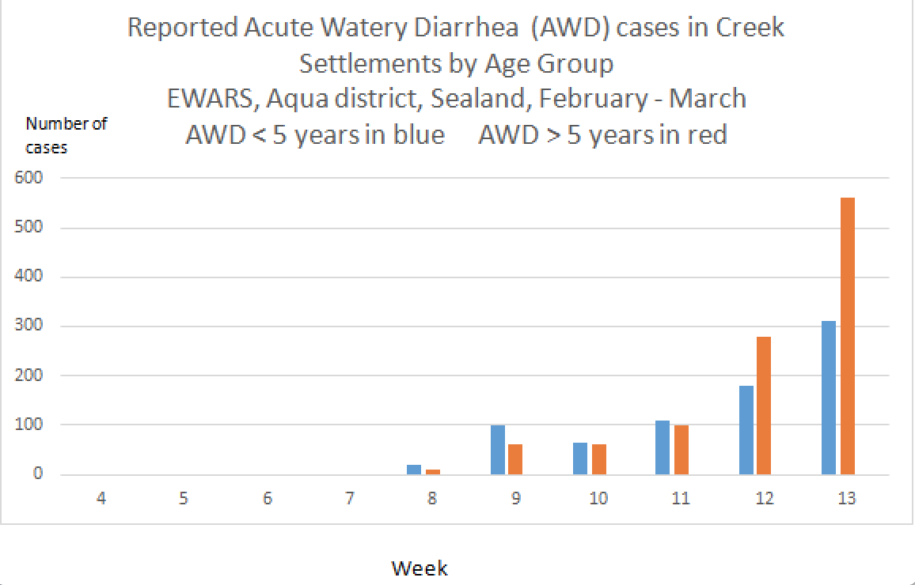

Situation overview
Over 20 organizations are present in the area to respond to the crisis, operating across the camps and settlements. However, there is limited oversight or coordination and services provided are not standardized and the quality varies.

In camp Ar and camp Bo there are basic health units. However, there is no process for analyzing health care coverage and assigning new facilities to under-served areas. The government hospital is overcrowded and does not have the resources to cope with the volume of referral patients.

The latest EWARS data shows that acute respiratory infections are the most commonly reported disease (29%), followed by fevers of unexplained origin (28%) and acute watery diarrhea (21%). The most recently published data on measles reports 13 suspected cases (2nd Mortality Morbidity Weekly Bulletin (MMWB) EWARS 23 March).

Potential outbreaks of diarrheal diseases, including cholera, are a concern, given the inadequate water and sanitation facilities in camps and settlements. The water quality data analysis of 21 sources and 75 household samples done by the district water authorities shows that just 35% of source samples and 7% of household samples are free from E. coli contamination.
▒UN agency March 25

Nutritional survey
Key findings:
Preliminary results of a nutrition assessment done in March in Ar Registered Refugee Camps have been released this week. The prevalence of acute malnutrition among children between 6 to 59 months is: GAM prevalence: 24.3% CI (19.5-29.7) - SAM prevalence: 7.5% CI (4.9-11.2)
▒ FMN (Fight Malnutrition Now) NGO

