**H.E.L.P. course Hawaii 2019**

**Week 2 Summary exercise**

**Session 1 THURSDAY**

Document 1: INSTRUCTIONS FOR H.E.L.P. COURSE PARTICIPANTS

**The Kayo refugee influx in Aqua district, Sealand**

**► Read the following scenario, discuss the current crisis in your group and prepare a list of the information that you will need to assess the situation for your organization. You will present the results of your discussion Friday morning.**

**SCENARIO**

Since 25 February, targeted violence against the Kayo community in Riverland has forced 50,000 people to seek refuge in the neighbouring country Sealand. The Government of Sealand opened its borders, and the local communities, authorities and frontline response have welcomed the Kayos into their already poor communities. Refugees are continuing to arrive daily, on foot, by boat and on makeshift rafts. They arrive exhausted and famished, often after having walked for days. They recount reports of extreme violence they have witnessed or experienced. Many have lost family members in their home villages or on the way and are deeply traumatized.

For many years, the Kayos have been deprived of their identity and nationality; they have not had regular access to basic human rights such as education, health care, or even regular access to food. Their freedom of movement in Riverland was always severely restricted.

*Source:UN monitoring document – March 30*

**Timeline:** we’re now in **March** ~ approximately **1 month after the onset** of the crisis on 25th February and there is a continuous flow of refugees crossing the border.

► **Your organization, the Universal Relief Organization (URO), an international organization, has decided to send a team to assess the situation in Aqua district, Sealand. The team includes a team leader, a spokesperson, a security and safety officer, and health-, nutrition-, public health engineering-, and protection specialists.**

**Your headquarter office has been able to pull together additional information from a variety of sources. Read seven documents: A map + graph, BBC news, UN reports, ACAPS report, ICRC report.**

► **Before leaving for Aqua district, discuss with your team what further information you will need to assess the situation.**

**H.E.L.P. course – Hawaii 2019**

**Session 1 THURSDAY**

**The Kayo refugee influx in Aqua district, Sealand**

Cumulative Kayo Refugees

Including pre-existing population

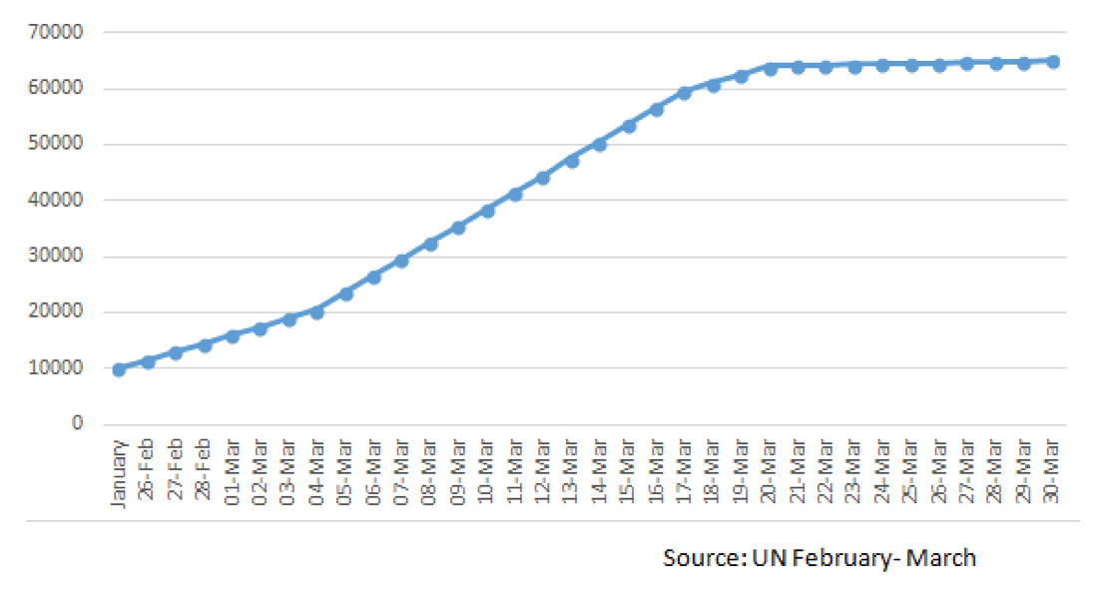

**H.E.L.P. course – Hawaii 2019**

**Session 1 THURSDAY**

**The Kayo refugee influx in Aqua district, Sealand**

Information available at your organization’s headquarters in Faraway town:

# Riverland Kayo crisis: UN 'on full alert' for new exodus

The UN refugee agency says it is on full alert for a new escalation in the Riverland crisis after more than 3000 Kayos crossed the border into Sealand on Monday. Speaking in Geneva, UN officials said many of the new arrivals had walked for days to reach safety. Last week, an average of 1500 people a day crossed from Riverland to Sealand. The UN has said that many of the new arrivals are traumatized after fleeing killings and burning villages. ‘’We're back in a situation of full alert as far as influxes are concerned. It is a big increase to see 3000 refugees in one day’’ UN High Commissioner for Refugees (UNHCR) spokesman told reporters in Geneva. The BBC’s learnt in Geneva that the UNHCR and aid workers are already struggling to support more than 12’000 who have already fled in recent weeks.

Currently, approximately 17’000 Kayos have fled Riverland since the beginning of the current crisis. The Kayo minority is widely disliked in Riverland. Those who have fled accuse the military of using a brutal campaign of killings and village burnings to try to drive them out. The military has been widely accused of conducting ethnic cleansing and genocide, but it has rejected all these allegations, saying it has only targeted the militants who have used violence against other communities.

▒ From the BBC – 10th March

**H.E.L.P. course – Hawaii 2019**

**Session 1 THURSDAY**

**The Kayo refugee influx in Aqua district, Sealand**

Information available at your organization’s headquarters in Faraway town:

More than 50,000 Kayo refugees are estimated to be sheltering in Sealand, having fled violence and persecution in Riverland. Violence, which began on 25 February has triggered a massive and swift refugee influx across the border. These refugees have joined 10,000 people who were already in Sealand following earlier waves of displacement. The Kayo population in Aqua district is highly vulnerable, many having experienced severe trauma, and are now living in extremely difficult conditions.

The existing refugees, along with the unprecedented volume of new arrivals, have put an immense strain on infrastructure, services and the host population, overwhelming the existing response capacity. Most of those who have arrived came with very few possessions. They are now reliant on humanitarian assistance for food, and other life-saving needs. Population movements remain highly fluid, with people settling in pre-existing makeshift or spontaneous sites before infrastructure and services have been established. Many sites are alarmingly overcrowded, exacerbating risks to people’s security, safety and wellbeing. In these highly congested conditions there is an increasingly high risk of an outbreak of disease.

Many of the new arrivals are visibly traumatized, suffering from the consequences of extreme violence, from the loss of or separation from family members, and from the ordeal of the displacement. Rape, human trafficking, and survival sex have been reported among the existing perils for women and girls while fleeing. Children’s well-being and mental and physical development is affected by the incidents that led to their fleeing and there are growing numbers of separated and unaccompanied children being reported. Newly arrived children have not been able to access education since their arrival. Protection interventions are needed to ensure that protection responses and services reach those most in need.

The Government of Sealand has triggered a widespread response across Ministries, agencies, and the Military, and on 14 March, allocated land for the establishment of a new camp. Local communities have been at the frontline of the response, providing food and basic items for new arrivals. National and international humanitarian agencies have rapidly responded in support of Government efforts. However, the scale of needs dramatically exceeds the current national and local capacity to deliver. A rapid scale-up and comprehensive humanitarian response by all partners is critical at this stage.

▒ Source UN Humanitarian Response Plan, March 30th

**H.E.L.P. course – Hawaii 2019**

**Session 1 THURSDAY**

**The Kayo refugee influx in Aqua district, Sealand**

Information available at your organization’s headquarters in Faraway town:

Among the new arrivals, 80% are estimated to be children and women. According to reports from IOM, 58% of the current influx are children and 10% are pregnant and lactating mothers.

*▒ UNICEF. Sealand Humanitarian Situation Report No 5 (Kayo influx). 28 March.*

Aqua is a district of southern Sealand, bordering Riverland. The Kayo population fleeing violence in Riverland now mostly reside in camps and settlements (91%), or Sealandi villages in Aqua district. There are four sub-districts in Aqua. Sub-districts One and Two have the largest Kayo populations with all official camps and settlements located in these two sub-districts. The largest settlement is in sub-district One and there are over 25,000 Kayo people. In sub-district Two there is a more even distribution of people between host communities and refugees.

There are generally four groups distinguished:

* Kayos in registered camps: Kayo people living in Refugee Camp Ar and Refugee Camp Bo. This includes both registered refugees prior to the February influx as well as new arrivals.
* Kayos in settlements: Unregistered Kayo people living in settlements.
* Kayos in host communities: Kayo population living among the host community
* Host community: Sealandi people and villages directly or indirectly affected by the Kayo influx.

**The delineation of host communities and makeshift settlements is not always clear as settlements continue to grow and expand into Sealandi communities.**

.

*▒ Source ACAPS 30 March*

**H.E.L.P. course – Hawaii 2019**

**Session 1 THURSDAY**

**The Kayo refugee influx in Aqua district, Sealand**

Information available at your organization’s headquarters in Faraway town:

"All communities affected by the violence are suffering, and the ICRC is deeply concerned about the conditions of families hit by this crisis," said Henri Dufour, ICRC spokesperson in Geneva.

Since February, more than 45’000 people have crossed into Sealand from Riverland, fleeing violence in their home areas. After walking for several days or taking a boat, they often arrive exhausted and traumatized. The ICRC is working closely with the Riverland Red Cross (RRCS) and the Sealand Red Crescent (SRCS), and community volunteers to respond to this emergency. "We are doing our best to address the needs of all people and communities affected by this tragic situation," said the ICRC's Henri Dufour.

▒ From the ICRC – 25th March